Hands On Exercises - Serialization

**Setup Instructions:**

1. Create a new Java Project called “SerializeTest”.
2. Copy the classes from the serialization module “ **SerializeAndDeserializeCurrentTime”** of Day 8 training into your project.
3. Maintain the same package structure.
4. Modify the classes as instructed.

Assignment 01

1. Modify the PersistentTime.java as shown below.  The change is to add another field to the PersistentTime class after the serialization.



1. Build and run the Deserialization part of the project

* Right click **DeserializeTime.java**project and select **Run File.**
* Observe the **java.io.InvalidClassException** exception in the **Output**window.

1. Modify the PersistentTime.java as shown below.  The change is to add unique version id to the class.



1. Build and run the Serialization part of the project.

* Right click **SerializeTime.java**project and select **Run File.**
* Observe the result in the **Output**window.



1. Modify the PersistentTime.java as shown below.  The change is to add another field to the PersistentTime class after the serialization.

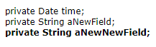

1. Build and run the Deserialization part of the project

* Right click **DeserializeTime.java**project and select **Run File.**
* Observe the result in the **Output**window.



### Summary

In this exercise,  you have learned how to do version control for serialization and deserialization of an object.

Assignment 02

1. Create a class **SerializeAnimationThreadNotStarted as below.**

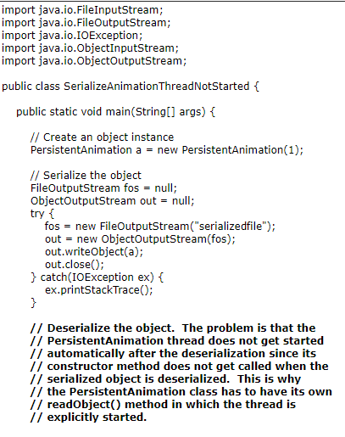

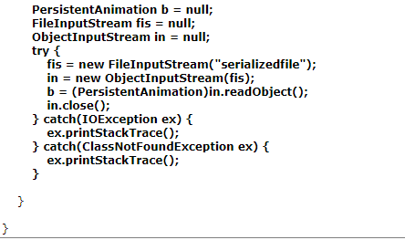

1. Write **PersistentAnimation**.java as shown below.

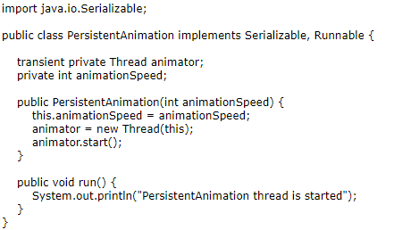

1. Build and run the project

* Right click **SerializeAnimationThreadNotStarted**project and select **Run**.
* Observe the result in the **Output**window. (Figure-3.13 below)  Observe that the thread is not started automatically when the object is deserialized.



1. Modify PersistentAnimation.java as shown below.  The code fragments that need to be changed are highlighted in bold and blue-colored font.

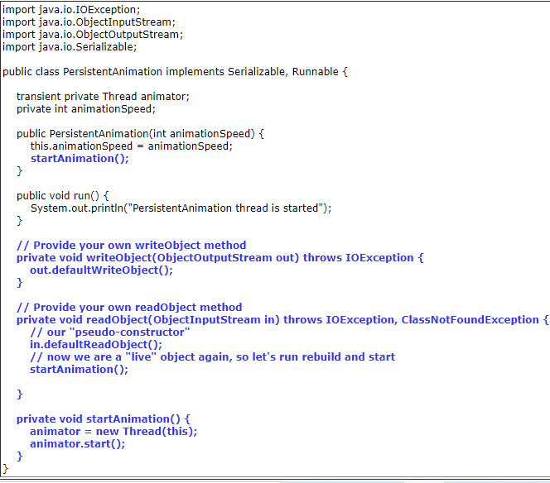

1. Build and run the project

* Right click **SerializeAnimationThreadStarted**project and select **Run**.
* Observe the result in the **Output**window.   Observe that the thread is now started when the object is deserialized.



### Summary

In this exercise, you learned how to provide your own readObject() and writeObject() methods, thus changing the behavior of the default protocol.

****************************************************************************************************************************